**Table of Contents**

1. INTRODUCTION 1
   1. Introduction: 1
   2. Objectives: 1
   3. Scopes and Limitations 2
      1. Scope 2
      2. Limitations 2
2. PROCESS MODEL 3
3. COST-BENEFIT ANALYSIS 4
   1. NPV 5
   2. ROI and Payback Period 6
   3. IRR 6
4. PROJECT PLANNING AND SCHEDULING 8
   1. Activity Planning 8
      1. Work Breakdown Structure 8
      2. PERT 10
      3. CPM 11
   2. Project Schedule 12
      1. Ball Chart: 13
      2. Gantt Chart: 14
5. RISK ANALYSIS 15
   1. Risk Identification 15
      1. Project risk 16
      2. Budget Risk 16
      3. Product risk 16
      4. Business risk 16
   2. Risk solving 16
6. RESOURCE ALLOCATION 17
7. TESTING 20
   1. Login Validation test 1: 20
   2. Checkout process test 2: 20
   3. Search Option: test 3 21
   4. Search Option: test 3 21
   5. Integrated Testing 22
8. CONCLUSION 23

# INTRODUCTION

## Introduction:

The project entitled “Online Mobile Phone Shopping” enables customer to buy mobiles or accessories from anywhere through online. This application advertises some of the products for shopping.

To buy products, customer has to create an account. Those who does not have an account, they can only view the available product. They can’t buy it. Once the customer has created account, not only he can view the products, he can also add the product to the cart and also, he can place an order to buy those products. A Wishlist is also added to the project for the user’s better experience in shopping. Wishlist enables users to store their choices in their accounts storage from where they can make a purchase later or can remove them if they no longer need the item. This application then generates bill for that particular customer. After the confirmation, the customer has to enter his credit card details to buy those products.

This project is aimed at developing a Web application that depicts online Shopping of mobiles and purchasing using Payment Gateway. Using this software, companies can improve the efficiency of their services. Online Shopping is one of the applications to improve the marketing of the company’s products. This web application involves all the features of the online shopping.

## Objectives:

The objective of this project is to develop an e-marketing or online mobile shopping system for selling of mobile phones. The Major Objectives of this project are as follows:

1. Helping the customer in searching their specific mobile with a user-friendly search tool.
2. Provide facility to the customers for online booking of mobile and adding to their Wishlist.
3. Informs customers about the delivery status notification system.
4. Provide a user-friendly user Interface for the customer for online sale of mobiles, facility to search desired mobile according to the given criteria.
5. Provide limited and secure environment for data access whenever required.
6. Provide easy access and smooth transition to the pages not requiring much training to the system users.

## Scopes and Limitations

### Scope:

* + - * Online Mobile Shopping system can be implemented in an averaged sized organization.
      * An Average company will not be very keen on spending loads of money on ledgers. Whereas these projects will greatly reduce the costs which is using common and cheap office items like database and desktop application.
      * The data is directly stored in database.

### Limitations:

The limitations to this Mobile shopping system are:

* + - * The analysis was performed by students who lacked prior experience in this field.
      * This case study report was carried out for learning purposes rather than for commercial purpose so certain aspects remained confidential for the system analyst and designers

# PROCESS MODEL

For this project, we have selected spiral development method which is the combination of both waterfall and iterative development method. Each phase in Spiral modal begins with a design goal and ends with the client reviewing the progress. We will be starting with a small set of requirements and go through each development phase for those set of requirements. Here, project manager will have a great influence because he/she would be deciding the number of phases required to build the project based on the project risks.

The reasons for choosing this method are:

* Additional functionality or changes can also be done at a later stage.
* Cost estimation becomes easy as the prototype building is done in small fragments.
* Development is fast and features are added in a systematic way
* There is always a space for customer feedback.

# COST-BENEFIT ANALYSIS

Cost Benefit Analysis (CBA) is an approach to evaluate cost and benefits of the proposed project in order to find the most cost-effective alternative. It is a technique that helps in comparing the expected costs and benefits of the alternative option and make choices accordingly. A CBA is a versatile method that is often used for business, project and public policy decisions. There are several techniques like NPV (Net-Present Value), IRR (Internal Rate of Return), BCR (Benefit-Cost Ratio) that can be used to analyze cost-benefit analysis. For our project we will be using Net Present Value (NPV) as a method for cost benefit analysis.

In order to calculate our CBA, first we need to assess the cost during the development and the benefits associated with the project. Some of the cost might include:

* Direct Cost
* Indirect Cost
* Intangible Cost
* Potential Risk
* Opportunity Costs

Benefits of Cost Benefit Analysis are:

* Improves decision-making
* Enhances understanding of project goals
* Helps compare information
* Increases chances of success
* Improves project planning

## NPV

Net Present Value (NPV) is a financial metric used to determine the present value of future cash flows, discounted at a specific rate. It is commonly used in capital budgeting to assess the profitability of an investment.

Key Takeaways:

* Net present value (NPV) is used to calculate the current value of a future stream of payments from a company, project, or investment.
* To calculate NPV, you need to estimate the timing and amount of future cash flows and pick a discount rate equal to the minimum acceptable rate of return.
* The discount rate may reflect your cost of capital or the returns available on alternative investments of comparable risk.
* If the NPV of a project or investment is positive, it means its rate of return will be above the discount rate.

The formula for the calculation of the Net Present Value (NPV) is:

𝑁𝑃𝑉 =

𝐶𝑎𝑠ℎ 𝑓𝑙𝑜𝑤

(1 + 𝑖)𝑡 − 𝑖𝑛𝑖𝑡𝑖𝑎𝑙 𝑖𝑛𝑣𝑒𝑠𝑡𝑚𝑒𝑛𝑡

Where, i = required return or discount rate t = Number of time periods

If analyzing a longer-tern project with multiple cash flows, then the formula for the NPV of the project is as follows:

𝑛

𝑅𝑡

𝑁𝑃𝑉 = ∑ (1 + 𝑖)𝑡

𝑡=0

Where, 𝑅𝑡 = net cash inflow-outflows during a single period t

i = discount rate or return that could be earned in alternative investment t = number of time periods

## ROI and Payback Period

ROI stands for Return on Investment; it is a financial ratio used to measure the profitability of an investment. It is typically calculated as a percentage by dividing the net profit of an investment by the cost of the investment. The higher the ROI, the more profitable the investment. The mathematical formula of ROI is:

𝑅𝑂𝐼 =

𝑃𝑟𝑜𝑓𝑖𝑡

𝑇𝑜𝑡𝑎𝑙 𝐼𝑛𝑣𝑒𝑠𝑡𝑚𝑒𝑛𝑡

∗ 100%

Payback period can be defined as the amount of time required to recover the cost of an investment through its cash flow. It can be calculated by dividing the initial investment cost by the average annual cashflows generated by the investment. The payback period can be calculated as:

𝑃𝑎𝑦𝑏𝑎𝑐𝑘 𝑃𝑒𝑟𝑖𝑜𝑑 = 𝑃𝑟𝑒𝑣𝑖𝑜𝑢𝑠 𝑦𝑒𝑎𝑟 +

𝑐𝑢𝑚𝑢𝑙𝑎𝑡𝑖𝑣𝑒 𝑑𝑖𝑠𝑐𝑜𝑢𝑛𝑡 𝑜𝑓 𝑝𝑟𝑒𝑣𝑖𝑜𝑢𝑠 𝑦𝑒𝑎𝑟

𝑐𝑢𝑚𝑢𝑙𝑎𝑡𝑖𝑣𝑒 𝑑𝑖𝑠𝑐𝑜𝑢𝑛𝑡 𝑜𝑓 𝑓𝑖𝑟𝑠𝑡 𝑝𝑜𝑠𝑖𝑡𝑖𝑣𝑒 𝑦𝑒𝑎𝑟

## IRR

IRR stands for Internal Rate of Return; it is a financial metric that is used to evaluate the performance of an investment or project. It is the rate at which the NPV of the investment cashflows equals zero. The higher the IRR the more profitable the investment or project. The formula for IRR is given as:

𝐼𝑅𝑅 =

𝑐𝑎𝑠ℎ 𝑓𝑙𝑜𝑤

(1 + 𝑟)𝑖 − 𝑖𝑛𝑖𝑡𝑖𝑎𝑙 𝑖𝑛𝑣𝑒𝑠𝑡𝑚𝑒𝑛𝑡

For the cost benefit analysis of our project, the initial investment be Rs 1,25,000 at the discount rate of 10%, expecting to generate the net cash flow of Rs 35000 per next 6 years.

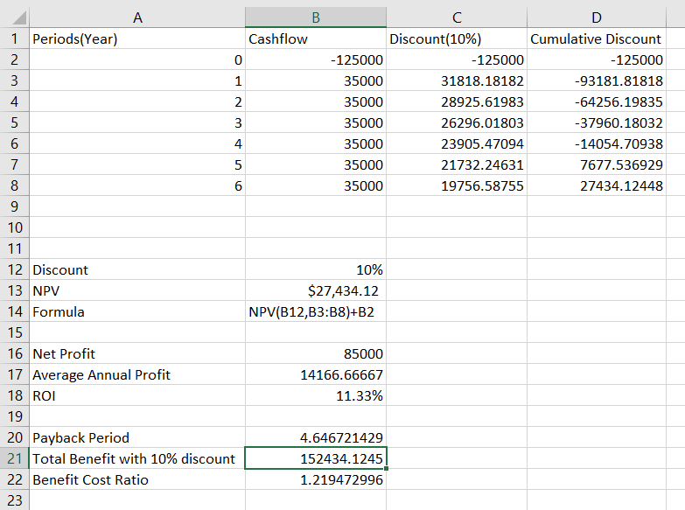

So, if discount rate is 10%, the project is worth the investment. Hence, our project group can undertake the project because NPV>0. Along with NPV, net. Profit, annual average profit, return on investment, payback period and benefit cost ratio were also calculated and their values are NPR 85,000, NPR 14,167, 11%, 4.646 years and 1.21 respectively.

# PROJECT PLANNING AND SCHEDULING

Project planning entails selecting and designing effective policies and methodologies to achieve project goals. Project scheduling is the process of assigning tasks and allocating appropriate resources to complete them within an estimated budget and time frame. Project planning and Project scheduling are the imported aspects of the management and are closely related that help to make the project successful. The stages in the project planning are as follow:

* Select project
* Identify project scope and objectives
* Build the project work breakdown structure
* Analyze the project characteristic
* Estimate resources
* Identify activity risks
* Allocate resources
* Review the plan
* Execute the plan

## Activity Planning

A project plan is a series of the activities stating the start and the stops of each activity in a project. Project planning and scheduling requires careful consideration and activity planning. It is an important part of project planning that involves breaking down of the project into specific tasks and activities, and deciding the order of the activities that should be completed in.

### Work Breakdown Structure

Breaking work into smaller tasks is a common productivity technique used to make the work more manageable and approachable. For projects, the Work Breakdown Structure (WBS) is the tool that utilizes this technique and is one of the most important project management documents. It singlehandedly integrates scope, cost and schedule baselines ensuring that project plans are in alignment.

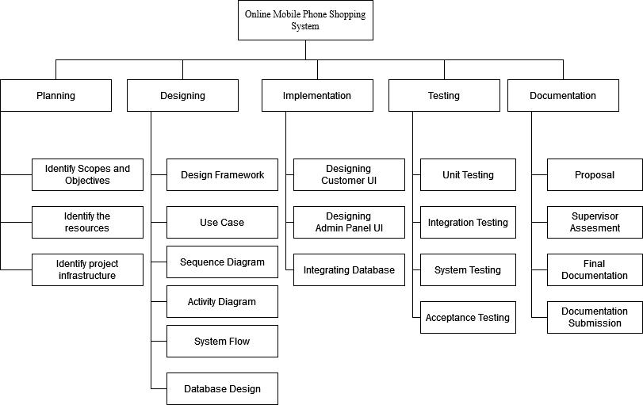

#### Figure 1: WBS of Online Mobile Shopping System

1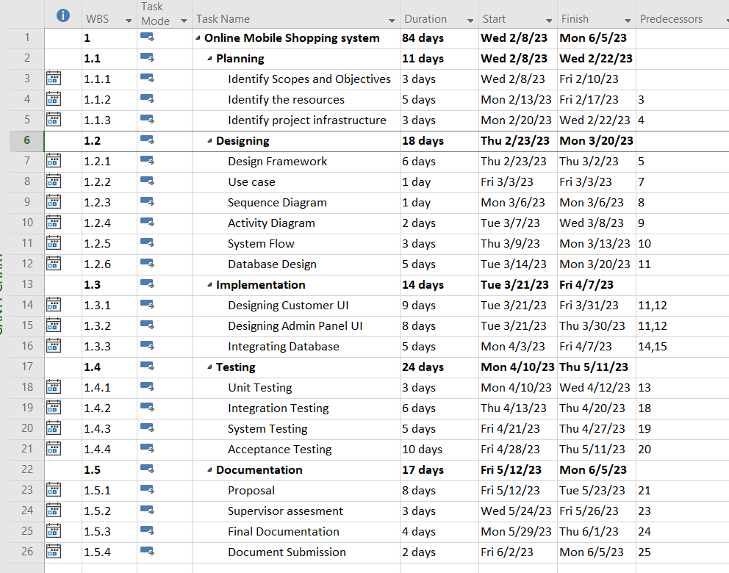

#### Figure 2: WBS in MS Project of Online Mobile Shopping System

### PERT

PERT (Program Evaluation and Review Technique) is a project management tool used to analyze and manage the tasks involved in completing a project. PERT uses a network diagram to represent the tasks and their dependencies, and estimates the time required to complete each task. The network diagram is created by identifying the tasks required to complete the project and the order in which they must be completed. Once the network diagram is created, PERT uses three-time estimates for each task: the optimistic time, the most likely time, and the pessimistic time. The optimistic time is the best-case scenario for completing the task, the pessimistic time is the worst-case scenario, and the most likely time is the most realistic

estimate. Using these time estimates, PERT calculates the expected time for each task using the formula:

Expected Time = (Optimistic Time + 4 * Most Likely Time + Pessimistic Time) / 6

### CPM

CPM (Critical Path Method) is a project management technique that is used to determine the critical path of a project, which is the sequence of tasks that must be completed on time in order to complete the project on schedule. A critical path in project management is the longest sequence of activities that must be finished on time in order for the entire project to be complete. Any delays in critical tasks will delay the rest of the project. CPM revolves around discovering the most important tasks in the project timeline, identifying task dependencies, and calculating task durations.

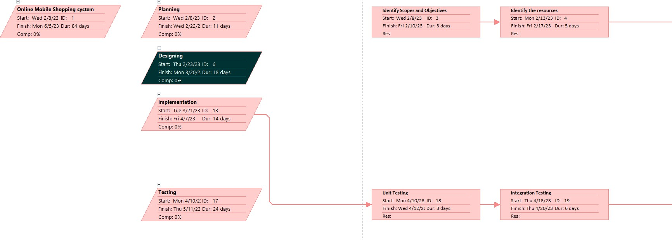

#### Figure 3: Network diagram Section 1

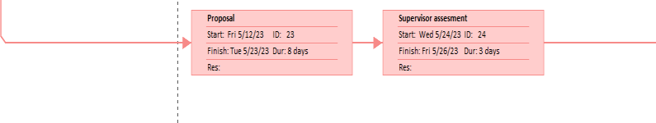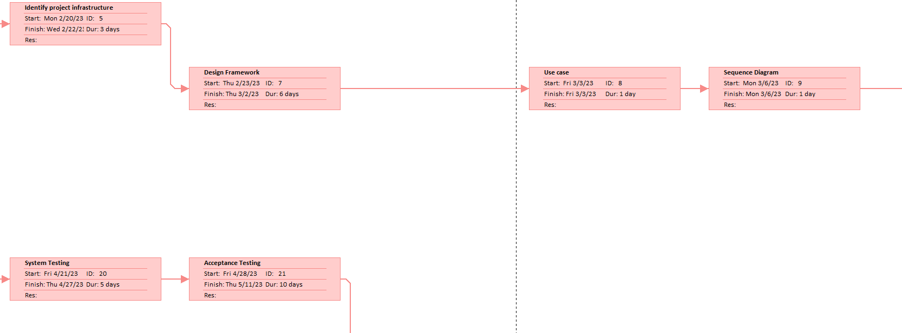

#### Figure 4: Network diagram Section 2

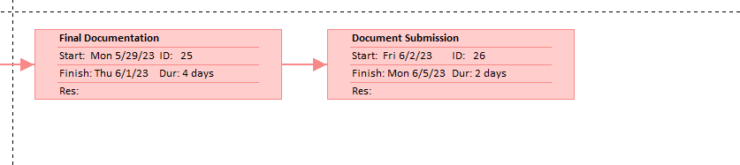

#### Figure 5: Network diagram Section 3

## Project Schedule

Project Scheduling is an essential aspect of the project management as it helps to plan and organize the project’s task and resources to ensure that the project is completed within the time. Generally, the scheduling refers to creating the timeline for a project, including the completed task, milestones and the resources required to meet them.

### Ball Chart:

The way of showing whether or not targets have been met or not. It is represented in the form of circles that indicate the start and the end point completion of activities. Circles of the ball chart mostly contain only two dates, the original and the revised one. An activity is denoted by a red circle and green color denotes that the activity is ahead of its schedule. Slippage in the project completion date but it is overcome by the timeline charts.

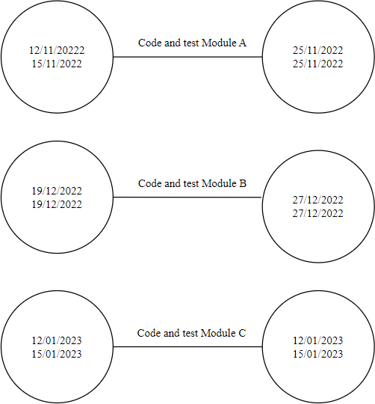

#### Figure 6: Ball Chart

### Gantt Chart:

Gantt Chart is used to track project progress. It is the simple and the oldest form of representing the progress of the project. It consists of an activity bar that indicates the scheduled activity dates and the duration along with the activity floats. Gantt chart can be defined as the horizontal bar chart which is used in project management to visually represent the project plan over time. It is the graphical representation of the project activities that aids in monitoring the progress of the project.

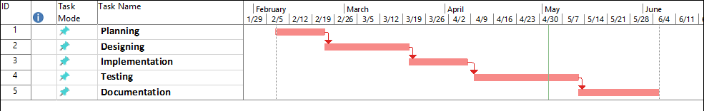

#### Figure 7: Gantt Chart of Online Mobile Shopping System

# RISK ANALYSIS

Risk Analysis and Management is a key project management practice to ensure that the least number of surprises occur while your project is underway. While we can never predict the future with certainty, we can apply a simple and streamlined risk management process to predict the uncertainties in the projects and minimize the occurrence or impact of these uncertainties. This improves the chance of successful project completion and reduces the consequences of those risks.

Risk can be defined as the uncertain events that may or may not occur during the project. On the contrary the project risk could either have a positive or a negative effect on the progress toward the project objectives. The identification and the management of those risk are the keys to ensure that the project progress runs smoothly without any barricade. While there is no way to predict the risk that can occur in the future with a certainty, but there are several methods that can be applied to predict those uncertainties and minimize the occurrence and the impact those risk has on the project.

## Risk Identification

Risks are to be identified and dealt with as early as possible in the project. Risk identification is done throughout the project life cycle, with special emphasis during the key milestones.

Risk identification is one of the key topics in the regular project status and reporting meetings. Some risks may be readily apparent to the project team—known risks; others will take more rigor to uncover, but are still predictable.

The medium for recording all identified risks throughout the project is the risk register, which is stored in the central project server.

There are multiple types of the risk that might be identified during the development of the system. The risk that might occur are as follow:

### Project risk

* + - * The experience staff in the team leave the project before it is finish, or someone was ill.
      * The methodology to solve the problem can't work in a proper manner.
      * Hardware requirement can't come in the time.

### Budget Risk

* + - * There is not enough budget causing delay in the progress of the system.

### Product risk

* + - * Package and development tool is not enough.
      * Can’t found suitable component.

### Business risk

* + - * Marketing product unsuccessful.
      * Competition from the similar products available in the market.

## Risk solving

There are several ways to solve the analyzed or the calculated risk. The solution to the risk identified above are as follow:

* The system can streamline the registration system by reducing the time and effort required from the staff and the students, which results in faster processing time.
* Improving the data security on the sensitive student details and reducing the risk of the security breach.
* To conduct regular system testing and quality assurance test to make sure that requirements are met.

# RESOURCE ALLOCATION

Resource allocation is the process of assigning and managing assets in a manner that supports an organization's strategic planning goals. Resource allocation includes managing tangible assets such as hardware to make the best use of softer assets such as human capital.

After the activities has been identified using the various techniques and tabulated using the Work Breakdown Structure the resources need to be allocated to complete the identified task. Managing tangible assets such as hardware to make the best use of softer assets such as human capital is an example of resource allocation. After the organization has established their goals then they must identify or determine which resources are required in order to fulfil those goals. Effective resource allocation in SPM requires continuous monitoring and adjustment during the whole project lifecycle so the resources get allocated and used effectively to get the desired output. Resource allocation involves balancing competing needs and priorities, and determining the best course of action to maximize the use of limited resources and get the best return on investment.

There are several types of the resources that is required in the project management and they are as follows:

* **People:**

This means the human members of the team, responsible for getting each task done.

This category is first for a reason. The people on your team have more influence over the success of your project than any other category.

You can have the best software, the cushiest office space, the most money, but if you don’t have a good team, your project won’t go anywhere.

* **Information**

Information is the knowledge you need to complete every task.

A team without information is just taking shots in the dark…and we all know how that ends. Your team members will come aboard with much of the information you need to get started. That includes how to use your tools, how to work within your company’s processes, and

other table-stakes stuff. The tricky part is the information specific to this project. It’s vitally important, and it’s also subject to change rapidly.

The information required for the online mobile shopping system may include the personal information such as name, address, contact details of the customers as well as the product details, engagement within a brand and its products, Wishlist etc. The system should also contain the information regarding the product attributes, functionalities, color variants and any other requirements

* **Material**

Material resources includes the raw materials and machines, tools, equipment, software, premises etc. They include both the resources that the organization possess or those that has to be leashed or purchased in order to carry out the project. The material resources can be any good which are made available temporarily for the project and can be used later in different project. The material resources required for Online Mobile shopping system are as follow: Laptops, database servers, office supplies, software licenses etc.

* **Financial**

Financial resources also called the cost resources, corresponds to the project budget, which will be designed prior to the launch by the project sponsors. The financial resources are used to manage the human and material resources, i.e., generally covering the renumeration of the actors of the project, the rental cost for the materials, and other cost such as travel expenses, product distribution expenses and miscellaneous expenses.

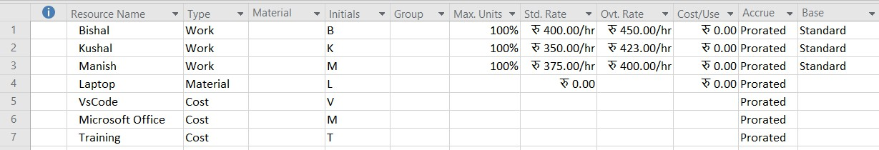

#### Figure 8: Resources used for project

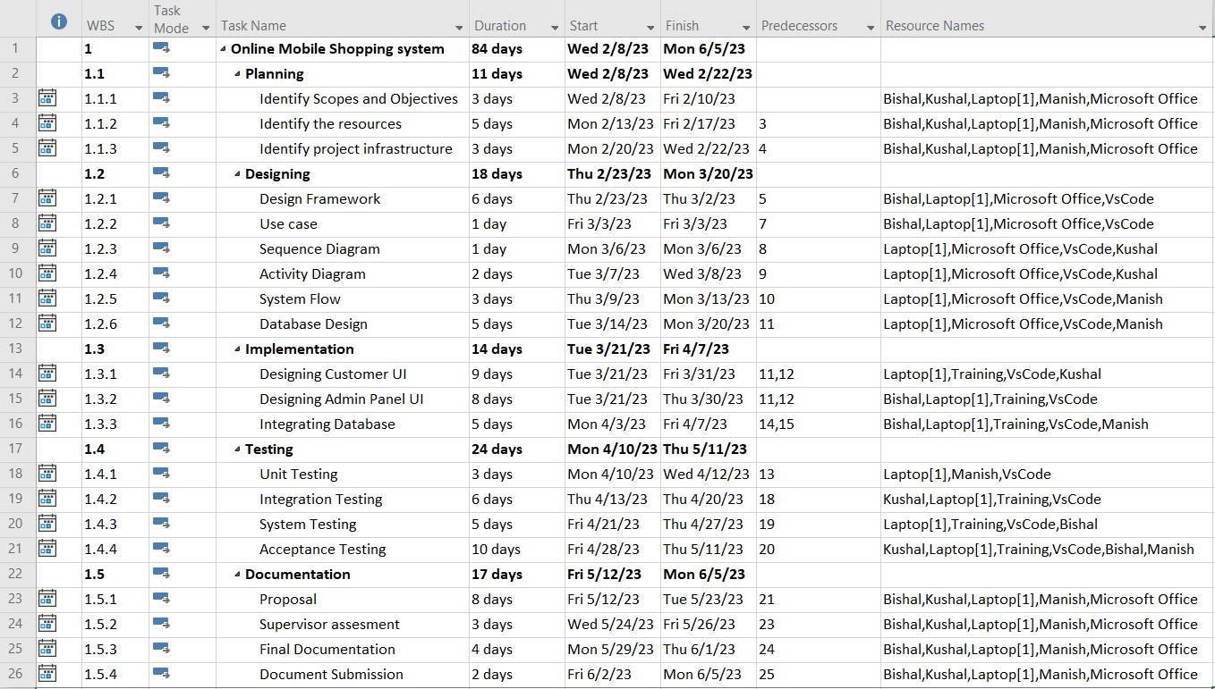

#### Figure 9: Resources Allocation

# TESTING

System testing, also referred to as system-level tests or system-integration testing, is the process in which a quality assurance (QA) team evaluates how the various components of an application interact together in the full, integrated system or application.

Before actually implementing the new system into operation, a test run of the system has been done for removing the bugs. It is an important phase of a successful system. After codifying the whole program of the system, a test plan should be developed and run-on a given set of test data. The output of the test run should match the expected results.

Some tests performed:

## Login Validation test 1:

**Description**:

The system is set up in such a way that a user simply cannot Access the Login until they Register first. Assuming the User is registered, the test is performed.

#### Table 1: User Login Unit Test

|  |  |  |  |  |  |
| --- | --- | --- | --- | --- | --- |
| Test  ID | Test Steps | Test Data | Expected  Result | Actual Result | Result(p/f) |
| 1 | Hover and click the Login button on  Navigation bar |  | Successfully able to login | Login Success | pass |
| 2 | Provide registered  Email or username. | [user@gmail.com](mailto:user@gmail.com) |
| 3 | Provide registered  Password | 1111 |
| 4 | login |  |

## Checkout process test 2:

**Description:**

The system is set up in such a way that a user simply cannot checkout without being Logged in first. Assuming the User is not logged in, the test is performed.

#### Table 2: Checkout Process Unit test

|  |  |  |  |  |  |
| --- | --- | --- | --- | --- | --- |
| Test  ID | Test Steps | Test Data | Expected Result | Actual Result | Result(p/f) |
| 1 | Hover and click the Checkout button on bottom right of Cart  page. |  | Redirect to login/Register Page | Successfully Redirected to Login/Register  Page | pass |

## Search Option: test 3

**Description:**

Testing to check if the Search bar on the navigation bar is working properly. Here the test data is ‘iPhone’. Assuming there is a product with ‘iPhone’ in their name.

#### Table 3: Searching Item Unit Test

|  |  |  |  |  |  |
| --- | --- | --- | --- | --- | --- |
| Test  ID | Test Steps | Test  Data | Expected Result | Actual  Result | Result(p/f) |
| 1 | Hover and click the Magnifying glass option to search on  Navigation Bar | iPhone | Successfully Display all the products that has iPhone in their name | Products displayed | pass |

## Search Option: test 3

**Description:**

Testing to check if the Search bar on the navigation bar is working properly. Here the test data is ‘apple. Assuming there is no product with ‘apple in their name.

#### Table 4: Searching Item Error Unit Test

|  |  |  |  |  |  |
| --- | --- | --- | --- | --- | --- |
| Test  ID | Test Steps | Test  Data | Expected Result | Actual Result | Result(p/f) |
| 1 | Hover and click the Magnifying glass option to search on  Navigation Bar | apple | “Data Not found” Message is to be displayed | Message displayed | pass |

## Integrated Testing

Integration Testing can be defined as the type of system testing where the system modules are integrated logically and tested as a group. The integration testing of our System is given below.

**Description:**

Integration testing of the system to register a user, login, add product to Wishlist, add product to cart.

#### Table 5: Integration testing of the system

|  |  |  |  |  |  |
| --- | --- | --- | --- | --- | --- |
| Test  ID | Test Steps | Test Data | Expected  Result | Actual Result | Result(p/f) |
| 1 | Hover and click the Login/Register button on Navigation bar and Register the  User | * Username * Email * Mobile number * Password | Successfully able to register | Registration Success | pass |
| 2 | Login user. | * Enter Email * Enter Password | Successfully  able to Login | Login Success | Pass |
| 3 | Search for a product and click on the add to cart button to add  the product to cart |  | Cart Must be updated | Cart Updated | Pass |
| 4 | Click on the Heart icon when user hover over the product to  add it to Wishlist. |  | Wishlist Must be updated | Wishlist updated | pass |

# CONCLUSION

Software Requirements Specification (SRS) document is to describe the external behavior of the Online Mobile Shopping System. Requirements Specification defines and describes the operations, interfaces, performance, and quality assurance requirements of the Online Mobile Shopping System. The document also describes the nonfunctional requirements such as the user interfaces. It also describes the design constraints that are to be considered when the system is to be designed, and other factors necessary to provide a complete and comprehensive description of the requirements for the software. The Software Requirements Specification (SRS) captures the complete or portion of software requirements for the system. Requirements described in this document are derived from the Vision Document prepared for the Online Mobile Shopping System. Using an open-source language gives us more flexibility, but at the same time it required more time to be programmed. The proposed Online Mobile Shopping System can be easily adopted by any Organization and retailers in order to make the mobile shopping and promoting their brand more secure and flexible. This system allows the users to buy phones which are of budget flagship or higher end flagship phones and pay either on Cash on delivery or via online banking method. This software helps in effectively managing the customers and their data. It provides the statistics about the number of customers and also the highest selling product on the website.